**What Is Off-Page SEO?**

Off-page SEO (search engine optimization**) refers to efforts to improve a website’s unpaid search engine rankings without making changes on the website itself**. Common tactics include link building, guest posting, and social media marketing.

**The goal of off-page SEO is to get search engines and users to see your site** as more **trustworthy and authoritative**.

It’s an essential part of a successful [SEO strategy](https://www.semrush.com/blog/seo-strategy/).

***Note***

*Off-page SEO is sometimes called off-site SEO or off-page optimization.*

**Why Is Off-Page SEO Important?**

**Think** about **off-page SEO** as **building your site’s reputation.**

And off-page **SEO factors like backlinks, reviews, and recommendations** **help** search engines **see your site as reputable**. **Which** can **lead to better visibility** in search results.

Off-page SEO plays a major role in your site’s ability to rank.

**On-Page SEO vs. Off-Page SEO**

While off-page SEO refers to optimization tactics applied **outside** your website, [on-page SEO](https://www.semrush.com/blog/on-page-seo/) refers to efforts applied **on your webpages**.

Here’s a quick overview of the tactics used in SEO—on-page and off-page:

**Both on-page and off-page** factors **play an important rol**e in [SEO](https://www.semrush.com/blog/what-is-seo/).

**But there’s** also [technical SEO](https://www.semrush.com/blog/technical-seo/) to consider. **This involves making site-wide technical** **improvements to things like security, loading speeds, and mobile-friendliness**. With the aim of improving search visibility.

**5 Off-Page SEO Techniques That Work**

Let’s take a look at five different off-page tactics you can use to boost your site’s authority and organic (unpaid) search traffic:

**1. Link Building**

[Link building](https://www.semrush.com/blog/link-building/) is the **process** of **getting other websites** **to link to your site**. In SEO, these **links** are **called**[**backlinks**](https://www.semrush.com/blog/what-are-backlinks/).

The **more backlinks** a page or domain has, the **more authoritative** it may **seem to Google**. **Especially if** those **backlinks** **come from domains** that are **authoritative themselves**.

**Semrush** measures a website’s authority with a metric called [Authority Score](https://www.semrush.com/kb/747-authority-score-backlink-scores). It’s based on the quality and quantity of backlinks, organic traffic levels, and the naturalness of the site’s entire backlink profile.

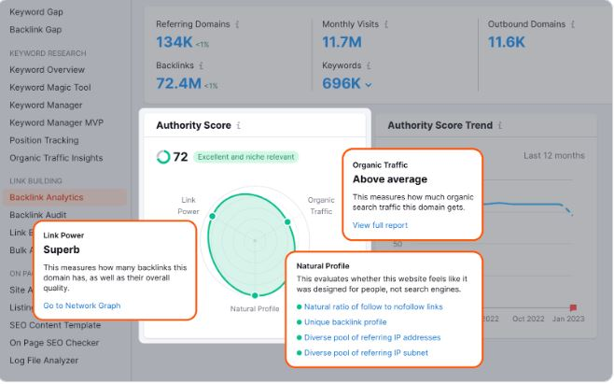

**Broken Link Building**

[Broken link building](https://www.semrush.com/blog/broken-link-building/) is the **process of finding** **relevant backlinks** that **don’t work properly** and convincing creators to update them with links to your site.

**Let’s say** an **industry publication linked to a competitor resource that has since been deleted.**

You could **contact** the **publication** to let them know the **link isn’t working**. And **suggest** **they link to your version of the resource instead.**

One of the **best ways** to find broken backlinks is with the [Backlink Analytics](https://www.semrush.com/analytics/backlinks/) tool.

Just enter your own or a competitor’s domain. Then, go to the “**Indexed Pages**” tab and apply the “**Broken Pages**” filter.

This will show you URLs that have backlinks but don’t work properly.

Look for pages that you have a good replacement for.

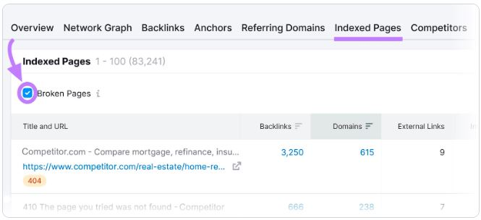

Then, click the “Backlinks” number in the corresponding row to see all the backlinks to the URL. These are the sites you might want to contact.

**2. Content Marketing**

[Content marketing](https://www.semrush.com/blog/what-is-content-marketing/) is an **important off-page SEO technique.**

**Publishing great content** is an **effective way to earn backlinks**, gain media attention.

Let’s look at **some of the best ways to distribute content you’ve created**:

**Social Media**

Social media **doesn’t directly impact Google rankings**. But it’s great for getting more attention.

The more people share your content on social media platforms, the **more traffic and links** to that **specific piece of content you’ll probably get**.

**And even if you don’t get a link or immediate traffic, you’ll get more attention. And more attention leads to more branded searches and mentions.**

That’s a win-win for your off-page SEO.

If you need a hand with your social media efforts, check out [Semrush Social](https://www.semrush.com/social-media/).

The app lets you schedule content on multiple platforms, track your social media performance, and much more.

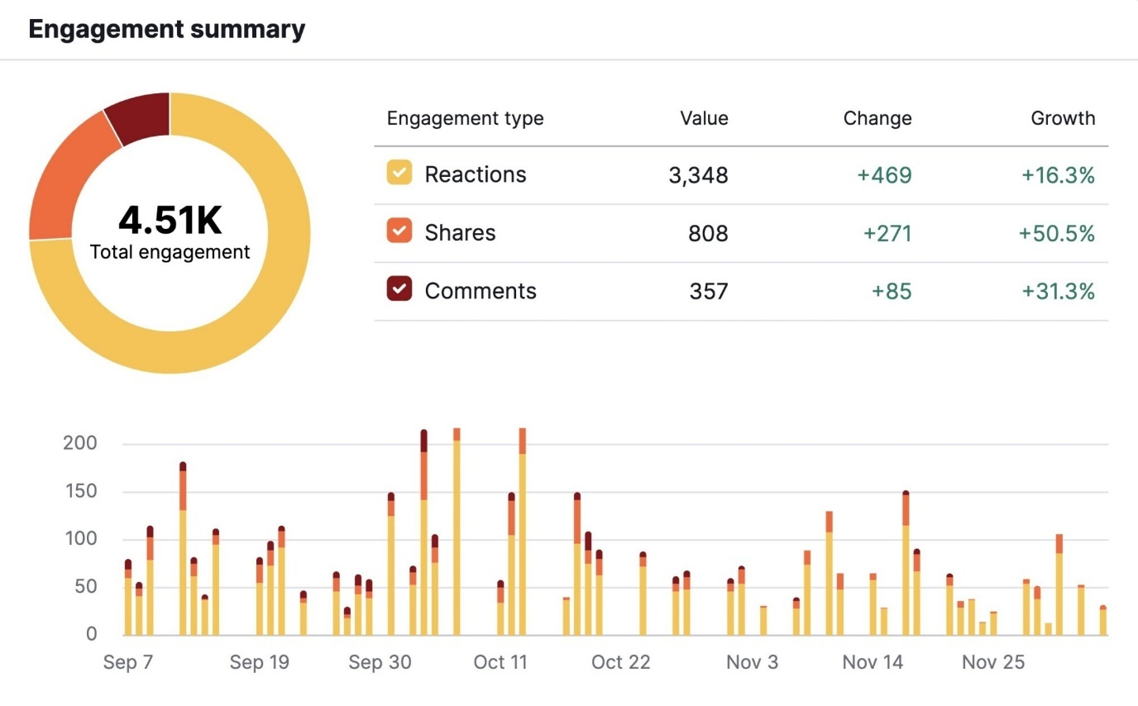

**Influencer Marketing**

[Influencer marketing](https://www.semrush.com/blog/influencer-marketing-guide/) involves **working with popular bloggers and social media creators to promote your products or services.**

It’s a **phenomenal way** to **build your brand**, amplify your content, and **reach new audiences.**

Influencers have large audiences. And can help ensure you’re present on relevant platforms.

.

For example, we can search for [YouTube influencers](https://www.semrush.com/blog/youtube-influencer-marketing/), as shown here:

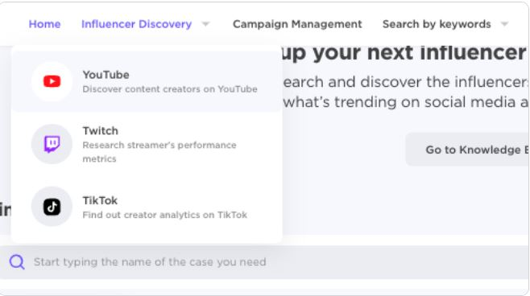

**Filter** by **the number of subscribers, category, price**, and more to find influencers who may be most helpful for your brand.

You’ll see a list of filtered results.

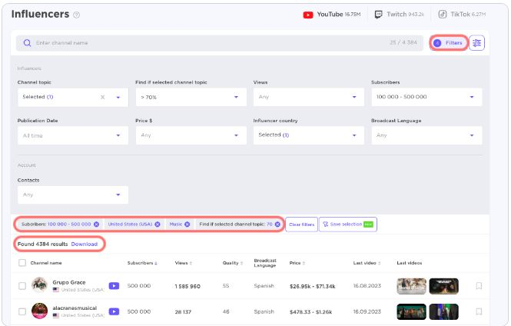

**Once you click** on the **influencer’s picture**, **you’ll see their engagement stats**. And a **contact email** **if it’s publicly listed**.

**Guest Posting**

[Guest posting](https://www.semrush.com/blog/guest-blogging/) **gets your brand in front of a different audience** and can lead to mentions and backlinks.

And **it can help** **with link building when done right**. You just need to make sure you’re **focusing on publications** that are **relevant to your niche** and that you’re focused on providing genuinely valuable information.

**Podcasts**

Podcasts are **immensely popular right now**. And that popularity shows no signs of slowing down.

If you are not using them as part of your [marketing strategy](https://www.semrush.com/blog/marketing-strategy/), you could be missing out on huge opportunities.

**Most businesses** still a**ren’t using podcasts**, so they’re a great way to gain a competitive advantage.

They also **enable you** to **reach new audiences**, share your expertise, **and gain visibility on other sites.**

And if you’re a guest on a podcast, they might link to your site. Or an external podcast could find your site and use it as a source somewhere in their description if it’s relevant.

If you know what a particular podcast usually covers, you can even reach out to them with a suggestion to link to your content in their show notes.

**Forums**

Dropping links in forums for SEO purposes won’t help you rank better in Google.

But **you can use forums** to get involved in **conversations that are related to your expertise.** To position yourself as an expert and help new audiences become aware of you.

Very few other platforms allow you to have open discussions with potential customers who are already asking questions about what you have to offer.

So, this is a fantastic way to begin building relationships and trust. And if community members want to know more, you can share relevant content they’ve expressed interest in

**3. Local SEO**

[Local SEO](https://www.semrush.com/blog/what-is-local-seo/) is the **process of optimizing your online presence** to **increase traffic, visibility, and brand awareness** in your business’s local area.

Let’s explore two off-page SEO techniques you should use as a local business:

**Google Business Profile Management**

[Google Business Profile](https://www.semrush.com/blog/google-my-business/) (GBP) is a free business listing tool that helps you influence how your business shows up in Google.

And because that occurs outside of your website, optimizing your Google Business Profile is a key off-page SEO tactic.

In fact, it’s a critical local SEO ranking factor.

And it can increase your site’s visibility in high-value positions on Google’s search results pages.

Like the map pack for our example, “plant store near me”:

Here’s what the Google Business Profile for one of those businesses looks like:

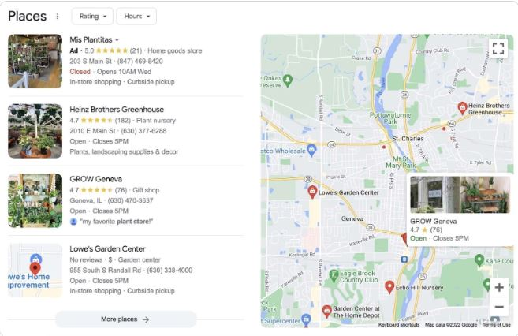

Here are a few Google Business Profile tips:

* Be meticulous with your contact information
* Respond to all reviews
* Publish posts regularly (including photos and videos)

If you want to learn more about this subject, read our guide on [Google Maps marketing](https://www.semrush.com/blog/google-maps-marketing-guide/).

**NAP SEO**

[NAP SEO](https://www.semrush.com/local/blog/nap-seo/) is the

process of getting your business’s correct name, address, and phone number (NAP) in online listings.

These citations usually appear in business directories, social media profiles, and review sites. But they can show up on all kinds of websites.

Like this:

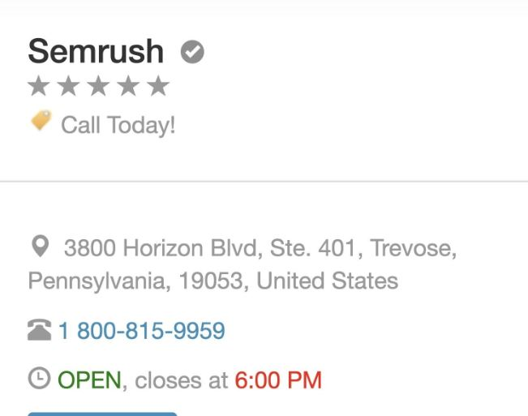

NAP citations are important because Google uses them to confirm that all your business information is accurate.

So, one of the keys to success with citations is consistency. Inconsistent citations are confusing to both people and search engines.

You must take the time to ensure that all of your NAP references match.

And a quick way to do that is to use our [Listing Management](https://www.semrush.com/listings-management/) tool.

Start by entering your business name and clicking the search icon.

You’ll see a dashboard with a summary of your overall online presence. Including reviews, listings with errors, and more.

Here are a few NAP citation tips:

* Keep your citations consistent everywhere
* Submit your information to niche and local websites
* Run monthly NAP audits

**4. Reviews**

Reviews can persuade others to trust your business.

In fact, reviews are one of the most important factors Google takes into account when evaluating your site’s reputability.

And they’re particularly important in local SEO.

Google recommends replying to all reviews. Good and bad. Doing so shows that you value your customers’ business and feedback.

You can quickly find and reply to reviews with [Review Management](https://www.semrush.com/review-management/) (part of [Listing Management](https://www.semrush.com/listings-management/)).

Once you’ve configured the tool, you’ll see a dashboard with all your reviews. To reply, just enter your comment in the tab and click “**Reply**.”

Here are a few tips for online reviews:

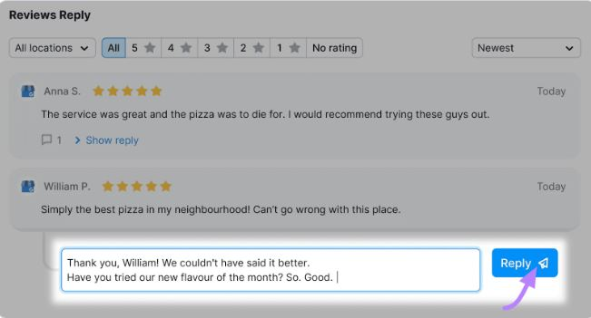

* Kindly ask all customers to leave reviews
* Build trust by responding to all reviews
* Don’t accept (or offer) money in exchange for reviews